Supplemental digital contents

Supplemental digital content 1: Setting up of TEAS and the stimulator

Supplemental digital content 2: ERAS approaches used in the study and comparison with conventional perioperative management

Supplemental digital content 3: Scales used for patients’ outcome assessment

Supplemental digital content 4: Questionnaire of QoR-15

Supplemental digital content 5: Definitions of postoperative major complications

Supplemental digital content 6: Nutritional Risk Screening

Supplemental digital content 7: Pre-existing diseases of the two group

Supplemental digital content 8: Case numbers of each center

Supplemental digital content 9: Subgroup analysis of primary endpoint based on type of surgery

Supplemental digital content 10: Kaplan-Meier estimation of incidence of first flatus

Supplemental digital content 11: Kaplan-Meier estimation of incidence of first defecation

Supplemental digital content 1. Setting up of TEAS and the stimulator. Bilateral LI4, PC6, ST36 and SP6 were used for TEAS.
TEAS: Transcutaneous Electrical acupoint stimulation.

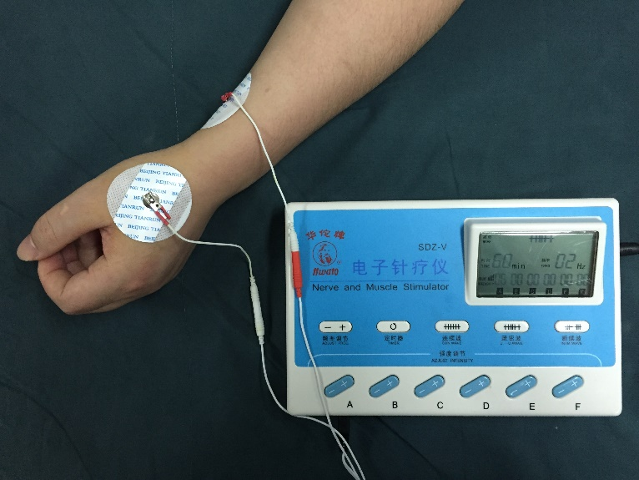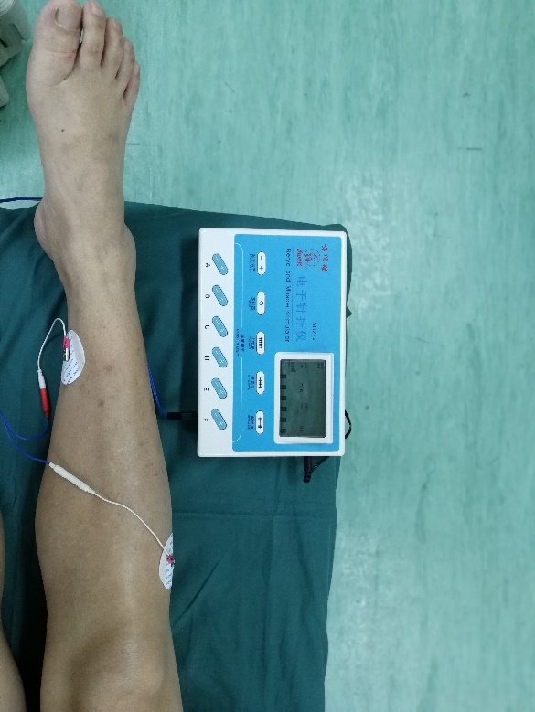
PC6
LI4
ST36
SP6

Supplemental digital content 2. ERAS approaches used in the study and comparison with conventional perioperative management

 | Conventional approaches | ERAS approaches
Fasting | Solid food: 8h; fluid:6h | Oral intake of 300 mL 14% carbohydrate drink 3 h before surgery
Bowel preparation | Routine bowel preparation | No bowel preparation
Thermal insulation during  Operation | No thermal insulation, room temperature was maintained at 22 ℃ | Thermal insulation of the body and extremities, body temperature was maintained above 36 ℃
Placement of abdominal drainage | Use of abdominal drainage tube | No routine use of abdominal drainage tube
Analgesia after operation | Standard use of patient-controlled analgesic pump, Infiltration of surgical wounds with ropivacaine at the end of surgery | Standard use of patient-controlled analgesic pump, Infiltration of surgical wounds with ropivacaine before incision
Mobilization after operation | Mobilize out of bed on patients’ own request | Encourage patients to mobilize out of bed
Intravenous nutrition after operation | Intravenous infusion of glucose saline and amino acid injection on the day of surgery. Parenteral nutrition before oral intake. Titrating fluid intake based on the liquid intake and output, and physiological need | Parenteral nutrition if oral intake is not adequate. Titrating fluid intake based on the volume of liquid intake and output, and physiological need
Removal of nasogastric tube | Removal of nasogastric tube after flatus | Removal of nasogastric tube within 24 h after surgery
Removal of urine catheter | Removal of urine catheter on the 3rd or 4th day after surgery | Removal of urine catheter within 24 h after surgery
Antibiotics | Standard use of antibiotics for 3 d after surgery | Standard use of antibiotics before and once after surgery

Supplemental digital content 3. Scales used for patients’ outcome assessment
Outcome | Assessment
Pain intensity
VAS | A scale of 10mm was used, 0 was for no pain, 10 was for pain that can’t be tolerated
Sleeping
VSS | A scale of 100mm was used, 0 was for good sleep, 100 was for totally insomnia
RCSQ | A brief 5-item questionnaire was used to evaluate perceived sleep depth, sleep latency (time to fall asleep), number of awakenings, efficiency (percentage of time awake), and sleep quality. Each RCSQ response was recorded on a 100-mm visual-analog scale, with higher scores representing better sleep and the mean score of these 5 items representing the overall sleep score
Recovery
QoR-15 | A questionnaire including 15 items was used to evaluate the quality of recovery after surgery. Each response was recorded on a 10-mm visual-analog scale, with higher score representing better recovery. Overall score is the sum of the 15 scores.
VAS: visual analogue scale; QoR: quality of recovery; VSS: visual sleeping scale; RCSQ: Richard-Campbell Sleep Questionnaire

Supplemental digital content 4. Questionnaire of QoR-15
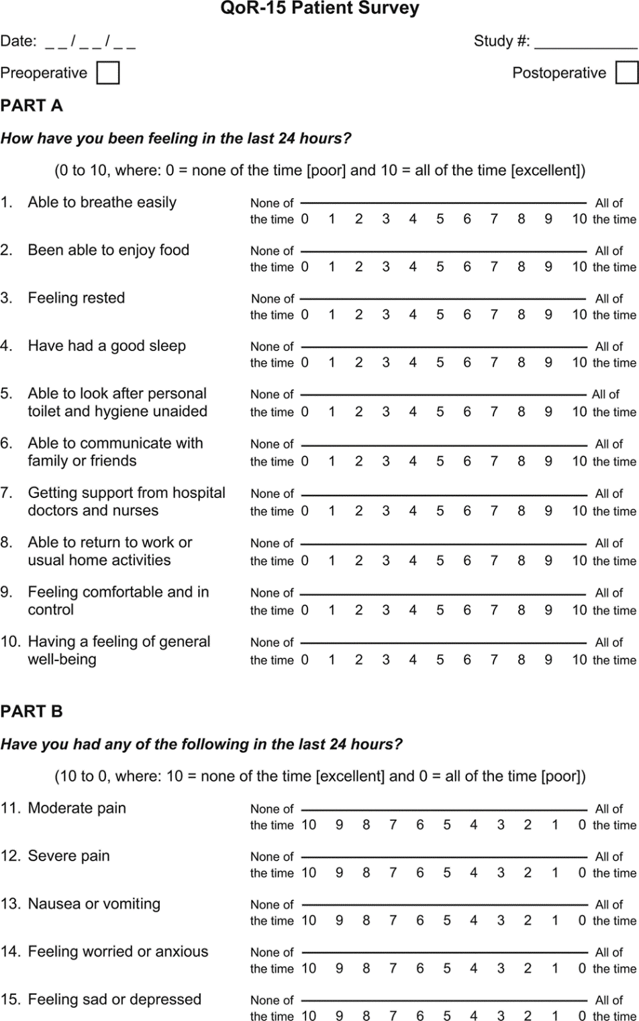

Supplemental digital content 5: Definitions of postoperative major complications
3.1 Postoperative pulmonary Complications
Postoperative pulmonary complications were scored on an ordinal scale of 1 to 4. We defined a clinically significant PPC as 2 or more items in the grade 2 complications or 1 item in the grade 3 or 4 complications.
Grade 1
- Cough, dry
- Micro-atelectasis: abnormal lung findings and temperature >37.5°C without other documented cause; results of chest radiograph either normal or unavailable
- Dyspnea, not due to other documented cause
Grade 2
- Cough, productive, not due to other documented cause
- Bronchospasm: new wheezing or preexistent wheezing resulting in change therapy
- Hypoxemia: a PaO₂ < 60 mmHg or SpO₂ < 90% on room air
- Atelectasis: radiological confirmation plus either temperature >37.5°C or abnormal lung findings
- Hypercarbia, transient, requiring treatment, such as naloxone or increased manual or mechanical ventilation
- Adverse reaction to pulmonary medication
Grade 3
- Pleural effusion, resulting in thoracentesis
- Pneumonia, suspected: radiological evidence without bacteriological confirmation
- Pneumonia, proved: radiological evidence and documentation of pathological organism by Gram stain or culture
- Pneumothorax
- Reintubation postoperative or intubation, period of ventilator dependence does not exceed 48 hours
Grade 4
- Ventilatory failure: postoperative ventilator dependence exceeding 48 hours, or reintubation with subsequent period of ventilator dependence exceeding 48 hours
3.2 Cardiovascular complications
Myocardial infarction: Detection of a rise and/or a fall of cardiac biomarker values (preferably cardiac troponin (cTn)) with at least one value above the 99th percentile upper reference limit (URL) and at least one of the following:
- Ischemic symptoms
- ECG changes of new ischemia (new ST–T changes or new LBBB)
- Development of pathologic Q waves in the ECG
- Imaging evidence of new loss of viable myocardium or new regional wall motion abnormality
- Identification of an intracoronary thrombus by angiography or autopsy
Angina: Chest pain with ECG changes
Congestive heart failure: symptoms and signs of left or right heart failure, and a documented effective response to therapy or impairment of left-ventricular function indicated by a documented LVEF of 35% or less within previous 2 years
Arrhythmia: diagnosed by ECG
Cardiac arrest: diagnosed by ECG
3.3 Other Complications
Renal dysfunction: Renal dysfunction was defined in 3 ways: (1) 25% reduction in creatinine clearance, as calculated by the Cockroft-Gault equation; (2) 50% increase in serum creatinine; and (3) 50% increase in serum creatinine with an abnormal peak serum creatinine (1.3 mg/dL for men and 1.0 mg/dL for women).
Renal failure: Rise in serum creatinine of ≥100umol/L or serum creatinine ≥300 umol/L, or need for haemofiltration or dialysis
Hepatic insufficient：Peak BIL>7mg/dL.
Hematological event: Requirement for any of the following within the last 24 hours: packed erythrocytes, platelets, fresh-frozen plasma or cryoprecipitate
Neurologic event: Presence of focal deficit, coma or confusion/delirium, NIHSS score
Re-exploration: Patients sent to OR for re-exploration under general anesthesia

Supplemental digital content 6. Nutritional Risk Screening (NRS2002)

Impaired nutritional status |  | Severity of disease
Absent  Score 0 | Normal nutritional status | Absent  Score 0 | Normal nutritional status
Mild Score 1 | Wt loss>5% in 3 months or food intake below 50-75% of normal requirement in preceding week | Mild Score 1 | Hip fracture chronic patients, in particular with acute complications:cirrhosis, COPD, chronic hemodialysis, diabetes, oncology
Moderate Score 2 | Wt loss>5% in 2 months or BMI 18.5-20.5 +impaired general condition or food intake 25-60% of normal requirement in preceding week | Moderate Score 2 | Major abdominal surgery, stroke, severe pneumonia, hematologic malignancy
Severe Score 3 | Wt loss>5% in 1 months(>15% in 3 months) or BMI <18.5 +impaired general condition or food intake 0-25% of normal requirement in preceding week | Severe Score 3 | Head injury, bone marrow transplantation, intensive care patients(APACHE>10)
Score | + | Score | =total score
Age | If>=70 yrs, add 1 to toatal score of the above |  | =age adjusted total score

The factors about nutritional status and severity of disease were evaluated on a 0–3 scale, with 0 indicating ‘low risk’ and 3 ‘high risk’. A total score was determined by summing the two factor scores, and patients 70 years and older had an additional point added to their total score. Patients with a total score of 3 or more (out of maximum score of 7) were considered to be at risk of malnutrition.

Supplemental digital content 7. Pre-existing diseases of the two group
Pre-existing disease | TEAS group | Control group
Myocardial ischemia | 5(10.6) | 1( 2.1)
Cardiac arrhythmia | 7(14.9) | 5(10.6)
Hypertension | 10(21.3) | 8(17.0)
Pneumonia proved by X-ray | 0( 0.0) | 2( 4.3)
Diabetes | 3( 6.4) 、 | 5(10.6)
Hepatic dysfunction | 0( 0.0) | 1( 2.1)
Renal dysfunction | 3( 6.4) | 0( 0.0)
White blood cell(×10⁹/L) | 6.9±3.6 | 6.1±2.8
Hemoglobin(g/dL) | 10.8±3.7 | 10.1±3.2
Platelet(×10¹²/L) | 83.4±139.2 | 101.2±132.8
INR | 1.0±0.1 | 1.0±0.1
ALT(IU/L) | 19.2±16.3 | 16.7±7.9
AST(IU/L) | 19.0±8.0 | 18.8±6.2
TBIL(μmol/L) | 10.1±5.8 | 11.7±6.3
BUN(mmol/L) | 7.0±13.7 | 4.5±1.1
Creatine (μmol/L) | 88.4±33.6 | 80.0±17.4
Data were presented as n (%) or mean±SD
TEAS: Transcutaneous electrical acupoint stimulation

Supplemental digital content 8: Case numbers of each center
Center | TEAS group |  | Control group
Center | ITT | mITT | ITT | mITT
No.1 | 20 | 18 | 23 | 21
No.2 | 25 | 24 | 21 | 20
No.3 | 5 | 5 | 6 | 6
Total | 50 | 47 | 50 | 47

Supplemental digital content 9. Subgroup analysis of primary endpoint (time to discharge) based on type of surgery
Type of surgery | TEAS | Control | P value
Left hemicolectomy | 5.2±0.9 | 6.5±1.5 | 0.002
Right emicolectomy | 6.2±1.0 | 7.1±1.9 | 0.03
Sigmoidectomy | 6.0±1.4 | 8.0±3.2 | 0.02

Data were mean±SD

Supplemental digital content 10: Kaplan-Meier estimation of incidence of first flatus
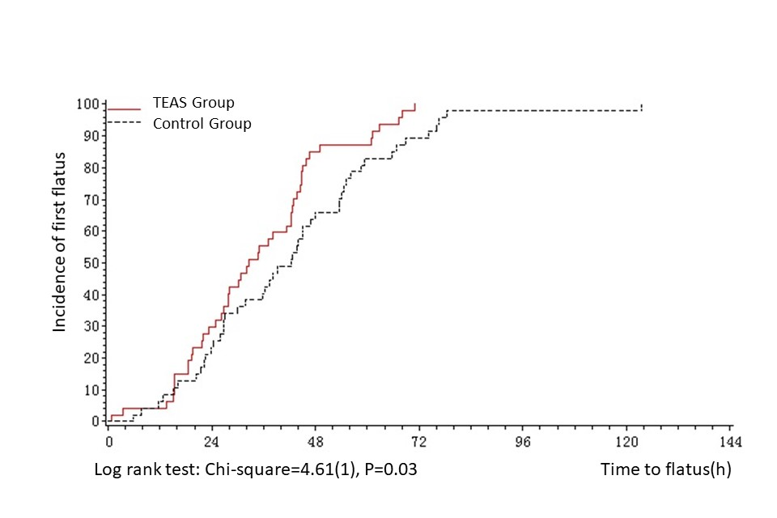

Supplemental digital content 11. Kaplan-Meier estimation of incidence of first defecation
